2012-13 UW Orthopaedic Surgery R1s

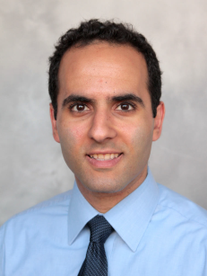
Ahmad Bayomy
University of Washington
School of Medicine

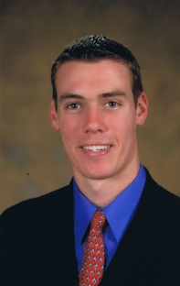
Kevin Hug
Duke University
School of Medicine

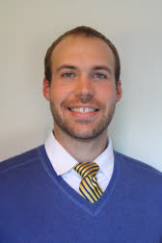
Calvin Schlepp
University of Washington
School of Medicine

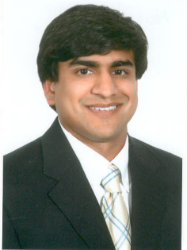
Neil Tarabadkar
Medical College of Georgia
School of Medicine
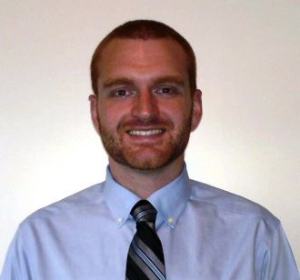
Christopher Domes
Oregon Health & Science University
School of Medicine

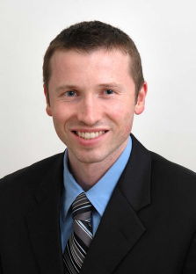
Alexander Lauder
Boston University
School of Medicine

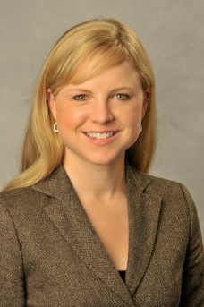
Sara Shippee
University of Illinois
College of Medicine

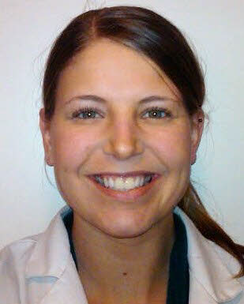
Shawn Werner
Oregon Health & Science University
School of Medicine

